M ON TH L Y S CH OOL
N E W SL E T T E R

News lette r Dece mbe r Vo lume 1, Issue 4

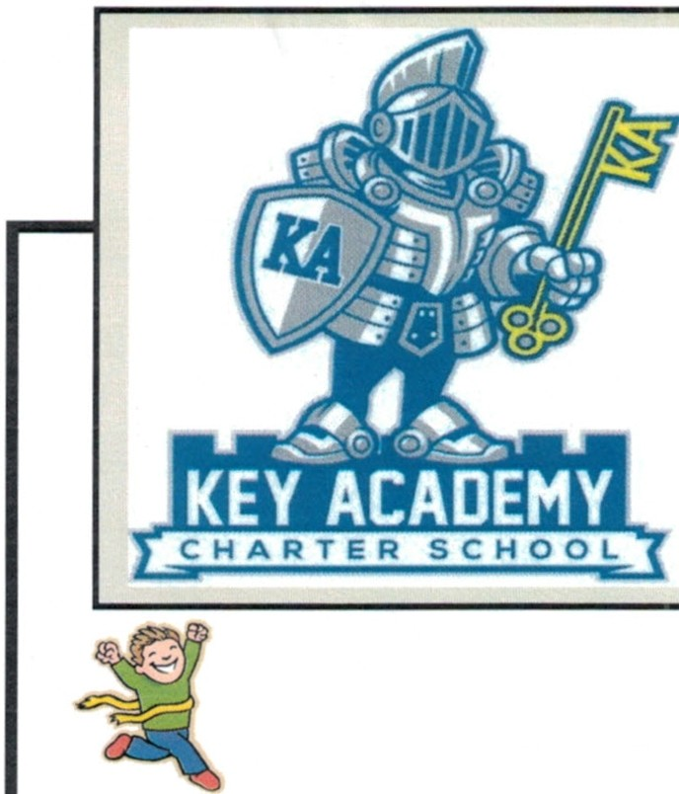

\Val k -a -thon/Jog-a -thon
On Friday, November 8th, we had our first annual Walk-a-thon/Jog-a-thon . It was a huge success! We raised $3,539.00, with the third grade class raising over $800.00. The money fundraised helped our School purchase new Elmo's and projectors for each classroom. We are excited to see this new technology inside our rooms!

During the event, Rogelio Gomez Merino ran/walked 107laps! He has set our record for next year and we look forward to seeing if it can be beat next year!
Anthony Montano and Jonathan Esteban Daniel also completed over 100 laps. Way to go!

A huge thank you goes to every parent who volunteered or donated items to make this event a memorable one! We cannot do it without your support and are grateful to have such a group of committed parents. A special thank you goes to the Thabatah family for donating the tee-shirts for the Walk-a-Thon.

If you would like to purchase a tee-shirt, there are a few still available in the Office.

Buy your KEY Acade my Spirit \Vear
KEY Academy tee-shirts and other items are available for purchase at the following website: http:/ /b1selfshops.com/husd _key_academy

Recess Games
We will be starting basketball very soon, but while we wait for the basketball court to be finished , we will start playing flag football. Flag football will be for students in grades 4-8. Students can sign up with Mr . Kasa this week if they would like to play. In addition, to playing games with Faith Ringgold, we are working with another school to join us in our games.

After School Program
The afterschool program has started. Currently, we have homework help offered on Monday and Wednesday for all grades from 3:30-4:15 pm in the Homework Club. We are also beginning to offer homework help on Tuesday and Thursday for grades
2nd, 3rd, and 6th. Students in grades other than 2nd, 3rd,
and 6th grade, please come to the office and speak with the Principal if you would like to participate in the Homework Club on Tuesday and Thursday afternoons.

On Monday and Wednesday, some students are required to stay for the Intervention/ELD program. If your student is not participating in this mandatory program, they can stay on Monday and Wednesday afternoons for the Homework Club. The Arabic Club will also be offered on Monday afternoons. Please see Ms. Sawsan if you would like to participate in this club.

On Tuesday and Thursdays we will be working with outside vendors to provide different enrichment programs for our students. These programs will have a fee associated to them and are subject to change depending on student participation and interest. At the moment, the Robotics club has started and will meet every Tuesday for next several weeks. The next club
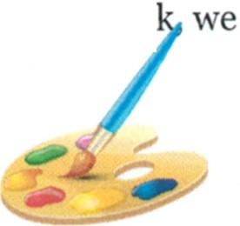that will be starting is Young Rembrandts . Make sure to sign up if you would like to join! After Winter Brea
will have more clubs added to the program.

Art Show
Please join us on Wednesday, December 18th for KEY Academy's Art Show. Currently, students are hard at work on their master pieces. Their work will be displayed for everyone to see on the December 18th from 5 pm - 6 pm. We are excited to see what these young artists will create! At the show, you are welcome to bid for the artwork. The artwork will be sold to the highest bidder .

Recycling
We are continuing to collect cans and plastics to recycle. Please check to make sure the cans and plastics have the recycle symbol on them before sending them to the School. Also, please bring your cans and plastics to the school every second Friday of the month. Mrs. Cruz has generously volunteered to take our recyclables to the recycling center for us .

KEY Academy School Newsletter
Page 2

The Great Debate
Throughout the month of November , fifth through eighth grade students worked together in groups preparing arguments for and against different current social issues. The groups presented at the Great Debate on November 21st. All students did a great job standing up on stage presenting their facts and
arguments. e winning teams will face off in the next round fot a chance to make it to first place on Thursday, December 19th .

The winning groups were :

- Tafai Muck , Stephanie Vasquez , Ali Seiuli-Phelps
- Najama Hassanzadh, Kaliana O'Donnell
- Odalys Arechiga , Arrend Voelker , Rogelio Gomez
- Ja'lon Harge, Juan Reyes, Muhammad Hammad
- Andrew Retamales , Tilomai Seiuli-Phelps , Maalik Albutmeh
- Anthony Montano , Leen Armoush , Kenia Juarez

Character Counts
We have been focusing on the character trait, responsibility.
On December 11th, the th/8th grade class will be presenting on responsibility and tell us what they have learned about being responsible .
After we have honored those students who have consistently shown to be responsible citizens , we will begin to look more closely at the character trait , fairness.
What does it mean to be fair?
Being fair is playing by the rules, taking turns, sharing and listening to what others have to say. Fair
people do not take advantage of others. They consider all sides before they decide, and they don't blame other people for something they did not do.
Let's all make the effort to practice being fair!

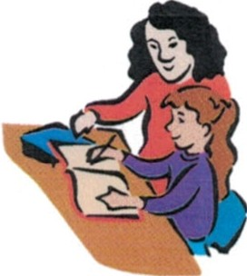...G.o..o.d.l.u.c.k..t.o..e.v.e.r.y.o.n.e.!.................................

Parent's Meeting
There will be a parent meeting on Tuesday, December 10th at 6 pm in the second grade
classroom. Feel free to join us as
! . '...• ••••••••••
: School Assembly Wednesday, Dec. 11th Parent Meeting

Don't

•• •• •• . FORGET!

we discuss the next events that we would like to have at the School.
'--------------- ----------------

Bring in your Box Tops !
Help us earn money for our school by clipping 10¢ Box Tops from hundreds of products an d bringing them back to the School.

You can find Box tops on :

  - Office supplies
  - Paper products
  - Storage containers
  - Baking goods

The class that brings the most will win a pizza party.

'' '
Tuesday, December 10th (5 pm-6 pm)
Art Show
Wednesday , Dec. 18th (5 pm-6 pm)
After School Program Every Monday & Wednesda y Robotics 101
Every Tuesday
Winter Break
Monday, Dec. 23rd-Friday, Jan. 3rd (NO SCHOOL)
........................................................

Parent Volunteers
Thank you so much to all the volunteers who have been helping around the school and donating supplies to the School. You support and dedication make all the difference!

-j "·T-he·m-e·a-sur·e-o·f -a m·a-n·'s-ch·a-ra·ct-er·i-s w·h-at·h-e·w-ou·l-d d·o-if·h-e ·k-new·-he·-ne·ve-r ·w-ou·ld-b·e-fo·u-nd·o-ut·."- ·.,
- - Baron Thomas B. Macauley I
'·- ·- ·- ·- ·- ·- ·- ·- ·- ·- ·- ·- ·- ·- ·- ·- ·- ·- ·- ·- ·- ·- ·- ·- ·-·- ·

